OVERVIEW

Trigger:

Asset(s) to be created, changed, or displayed.

Business Process Description Overview
The asset master record contains all information relating to an asset that remains unchanged over a longer period of time:
- Technical master data
- Organizational allocations (usually time-dependent)
- Depreciation terms
The system stores all the values and transaction data per each asset master record.
Assets can be represented differently in the FI-AA component according to their complexity. The structure of the master record is identical for all asset main numbers, asset sub-numbers and group assets. Therefore, the basic procedure for creating any of these objects is essentially the same.

Input - Required Fields | Field Value / Comments
Asset Class | Determines not only the asset grouping but screen layout and account determination.
Company Code | The company code to which the asset is assigned.
Description | A useful description for identifying the asset (non-generic)
Cost Center | Required if Controlling Module is active
Depreciation Key | Required for each depreciation area. These will default in based on the asset class but can be overridden.
Useful Life | Required for each depreciation area. These will default in based on the asset class but can be overridden.

Output - Results | Comments
Creation of An Asset Master Record

Tips and Tricks

Procedural Steps

1.1. Access transaction by:

Via Menus | Accounting → Financial Accounting → Fixed Assets → Asset → Create or Change or Display → Asset
Via Transaction Code | AS01 for Create, AS02 for Change, AS03 for Display

1.2. On “SAP R/3 Screen”, enter information in the fields as specified in the table below to create an asset. To display an asset, enter in the asset number, company code, and hit ENTER:
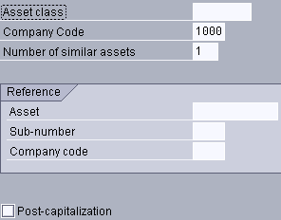

Field Name | Description | R/O/C | User Action and Values | Comments
Asset Class | The grouping which is the main driver for the assets accounting. | R |  | Determines the asset’s screen layout and account determination.
Company Code | The company code to which the asset is assigned. | R
Number of similar assets | Number of similar assets that you want the system to create. | O | Input quantity of similar assets available.
Reference Asset | Reference another asset to copy as starting point for new asset | O | Use if creating several similar assets. Screen layout of this asset will determine what information is copied to the asset.
Reference Sub Number | Reference Asset Sub Number | O
Reference Company Code | Reference Company Code of Asset | O
Post Capitalization | If yes, capitalization date will be a  Required field | O | Typically, asset master is created prior to actual collecting asset costs.
(NOTE: On the above table, in column “R/O/C”; “R”=Required, “O”=Optional, “C”=Conditional)

Press ENTER or Green Check icon to advance to the next screen.

On the "SAP R/3” Screen and Tab labeled "General", enter information in the fields as specified in the table below:

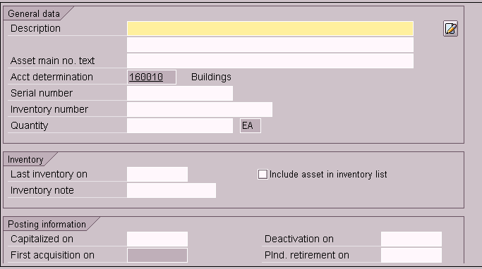

Field Name | Description | R/O/C | User Action and Values | Comments
Description | Description of asset | R | This should by a useful non-generic description of the asset
Description2 | Additional description | O | Use for model number or if more than 50 characters are needed for Description. | CCR number
Asset main no. text | Used in reporting and accessing totals via asset main number | O | This will automatically be populated by Description
Account determination | Rule for determining general ledger accounts. | R | System generated driven by the class.
Serial Number | Unique Mfc identifier of asset | O | Enter serial number of asset | Req’d by Fender
Inventory Number | The unique identifier of an asset | O | Asset Tag number
Quantity | Number of assets. | O | Used when grouping a number of assets under one asset.
Last Inventory on | When the asset was last inventoried. | O | Not used when creating a new asset record.
Include asset in inventory list | Will list asset in physical inventory list if checked | O | Check Box | ALWAYS YES
Inventory Note | Additional information regarding the asset’s inventory. | O | Not used when creating a new asset record.
Capitalized on | Date asset is put into service | O | Automatically populated from acquisition transaction | Required if post capitalization selected
Deactivation on | The retirement date of the asset | O | The system enters the asset value date of a retirement posting.
First Acquisition on | The date of the first acquisition posting | O | The system automatically inputs this field
Plnd Retirement on | Date of planned retirement | O | Use this if the asset has a known life of use.
Acquisition year | The year of acquisition | O | The system automatically inputs this field
Ordered on | The order date of the first purchase order for the asset. | O | The system automatically inputs this field
(NOTE: On the above table, in column “R/O/C”; “R”=Required, “O”=Optional, “C”=Conditional)

NOTE:
Some of the fields detailed above may not appear on your entry screen. The screen layout rule for the asset class will dictate the fields, which appear throughout the entire asset master record.

1.4. Click "Time-Dependent" Tab to continue creating asset and enter information in the fields as specified in the table below:
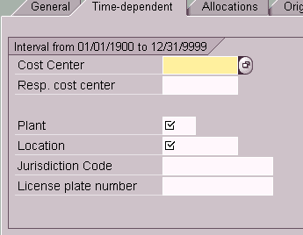

 | Description | R/O/C | User Action and Values | Comments
Business Area | Group of the enterprise uses to report | R | Required if using Business Areas. | Not Used
Cost Center | The unit to be charge with the asset’s depreciation or gain/loss. | R | Required if Controlling Module is active.
Resp Cost Center | The Cost Center responsible for maintaining the asset. | O
Plant | Plant in which the asset is located. | R | Used to do plant related analysis of the asset.
Location | Location with in the plant where the asset resides. | R | Used to do location-related analysis of the asset. Plant is required if location is used.
License Plate No. | The assigned license plate number for registered vehicles. | O | This is used for licensed vehicles and is usually shut off on other screen layouts. | FOR AUTO  CLASS ONLY
Jurisdiction Code | Tax jurisdiction code corresponding to the physical residence of the asset. | O | Enter tax jurisdiction code; drop down on field or F4.
(NOTE: On the above table, in column “R/O/C”; “R”=Required, “O”=Optional, “C”=Conditional)

  - Click "Allocations" Tab to continue creating asset and enter information in the fields as specified in the table below: (Entire tab is optional)
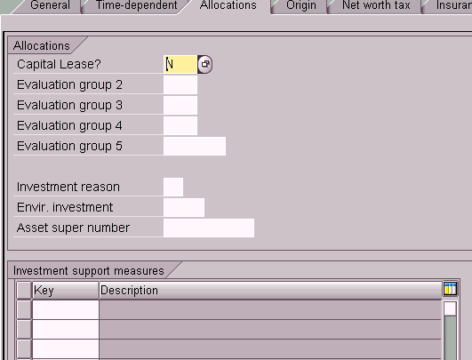

 | Description | R/O/C | User Action and Values | Comments
Capital Lease | Yes or No for capital lease | O | Used to define capital leases
Evaluation group 1 | User defined field | O | User defined field | 4 characters
Evaluation group 2 | User defined field | O | User defined field | 4 characters
Evaluation group 3 | User defined field | O | User defined field | 4 characters
Evaluation group 4 | User defined field | O | User defined field | 4 characters
Evaluation group 5 | User defined field | O | User defined field | 8 characters
Investment reason | Reason for asset investment or capital investment | O | Used in conjunction with Investment management to identify why the asset was purchased.
Asset super number | Asset super number to which asset is to be assigned | O | Data relating to the assets in a super number can be analyzed together
Investment support measures | Used to identify investment support measures | O | This will generated appropriate depreciation areas for the asset master record.
(NOTE: On the above table, in column “R/O/C”; “R”=Required, “O”=Optional, “C”=Conditional)

1.6. Click "Origin" Tab to continue creating asset and enter information in the fields as specified in the table below:

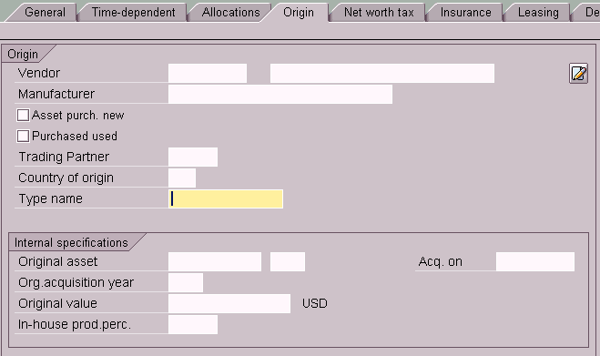

 | Description | R/O/C | User Action and Values | Comments
Vendor | Alphanumeric identifier of the vendor | C | May populate automatically from the purchasing information.
Name of Asset Vendor | Name of vendor | C | Populates based on the vendor number supplied in Vendor
Manufacturer | Manufacturer of asset. | O | Enter if known.
Asset purchased new | Indicator of the asset is purchase new. | O | Most assets will fall in this category. Asset must be indicated either new or used. | Req’d by Fender
Purchased used | Asset was purchase used or second hand. | O | Asset purchase used should be indicated for tax purposes. Asset must be indicated new or used. | Req’d by Fender
Trading Partner | Intercompany |  |  | NOT USED
Country of Origin |  | O | Informational Only | Not Needed
Type Name | Informational purposes only--- Used for asset model number | O | You can enter a description of the model of the asset type here.
Internal specifications: Original Asset/Yr/Value | Original Asset info. | C | If asset has been transferred, original asset information appears here. | TRANSFER  ONLY
(NOTE: On the above table, in column “R/O/C”; “R”=Required, “O”=Optional, “C”=Conditional)

1.7. Click "Net Worth" Tab to continue creating asset and enter information in the fields as specified in the table below: (This tab is used for property tax purposes).
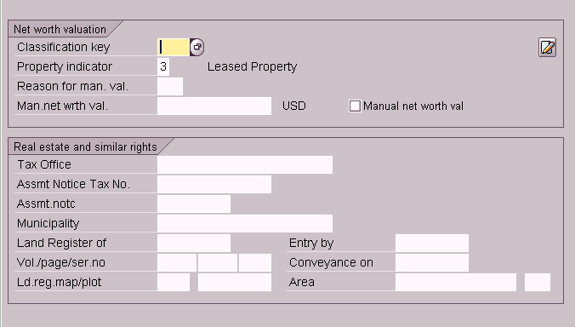
 | Description | R/O/C | User Action and Values | Comments
Classification key | Classify the fixed assets by net worth tax criteria. | O
Property indicator | Classify the asset according to property law requirements | R
Reason for man.val. | Reason for manual valuation | O
Man. Net worth val. | Net worth tax value of asset: assessment value. | O | Manually enter value. You also have to set the ‘manual net worth val” indicator. If you do not enter a manual net worth value, and only set the indicator, the system assumes a net worth value of zero.
Tax office | Tax office for piece of real estate | O | Informational purposes only
Assmt Notice Tax No. | Tax # of the assessment | O | Informational purposes only
Assmt. notc | Date of Last notice of assessment | O | Informational purposes only
Municipality | Local authority responsible for the real estate | O | Informational purposes only
Land Register of | The real estate register in which the land is entered. | O | Informational purposes only | Land Class
Entry by | Date of entry in the land register | O | Informational purposes only | Land Class
Vol./page/ser.no | Official real estate register; Real estate registration; Sequence num. of the entry in the land registry. | O | Informational purposes only
Conveyance on | Date of notarized transfer of ownership | O | Informational purposes only | Land Class
Ld. Reg.map/ plot | Land register map number; plot number. | O | Informational purposes only | Land Class
Area | Surface Area of land & area unit. | O | Informational purposes only | Land Class

  - Click “Insurance” Tab to continue creating asset and enter information in the fields as specified in the table below. (All for informational purposes only).

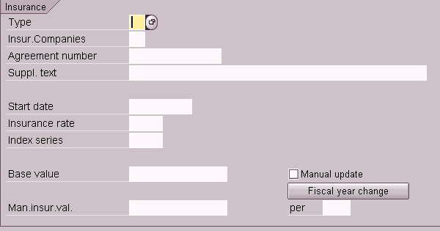

 | Description | R/O/C | User Action and Values | Comments
Type | Used to calculate the base insurable value. | O | Informational purposes only | NO VALUES
Insur. Companies | Insurance company of the asset | O | Informational purposes only
Agreement number | Policy number | O | Informational purposes only
Suppl. Text | Additional text relating to insurable asset. | O | Informational purposes only
Start Date | Date of insurance agreement | O | Informational purposes only
Insurance rate |  | O | Informational purposes only
Index series | For determining the insurable value | O | Informational purposes only
Base Value | Base insurable value for value as new insurance | O | Informational purposes only
Manual Update | Update value manually | O | Informational purposes only
Man. Insur. Val | Manual value | O | Informational purposes only;
Per | Fiscal year insurance value was manually maintained for last time | O | Informational purposes only

  - Click “Leasing” Tab (Only for leased assets) to continue creating asset and enter information in the fields as specified in the table below. (This is all used for informational purposes only).
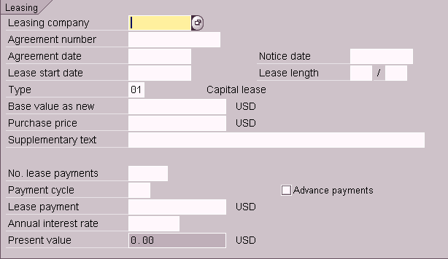

Field Name | Description | R/O/C | User Action and Values | Comments
Leasing Company | Alphanumeric identifier of the vendor | O
Agreement number | Lease number | O
Agreement date | You can enter the date of the leasing contract in this field. | O | This field is currently for informational purposes only.
Notice Date | You can enter the termination date of the lease here. | O | This field is currently for informational purposes only.
Lease start date | Date on which the leasing contract begins. | R
Lease length | Yrs/ Mos | O | Enter the length of the leasing agreement here in fiscal years.
Type | Capital or Operating lease | R | Automatically populated based on the asset class
Base value as new | You can specify the estimated market price of the leased asset here. | O | This theoretical purchase price can be displayed in the standard leasing report (for the identification of future lease liability) as the statistical acquisition cost.
Purchase Price | You can enter the purchase price of the leased asset after the lease has expired Price paid for equipment | C | This field is currently for informational purposes only.
Supplementary text | Additional info | O
No. lease payments | Total number of payments to be made to the lessor. | O | The system uses the number of lease payments to determine the present value of the leased asset.
Payment Cycle | Times a Year | O
Advance payments |  | O | Set this indicator, if the payments to the lessor are to be paid in advance.
Lease payment | The lease payment cycle determines the periodic intervals at which lease payments are made. | O | The system uses the lease payment cycle in determining the present value of the leased asset.
Annual interest rate |  | C/ O | Enter when Capital lease. The leasing interest rate serves to determine the cash value from the leasing payments
Present Value | Present value determined by the system for a leased asset. | O | Automatically calculated.

  - Click "Deprec. Area" Tab to continue creating asset and enter information in the fields as specified in the table below: (All of these values are defaulted from the asset class).

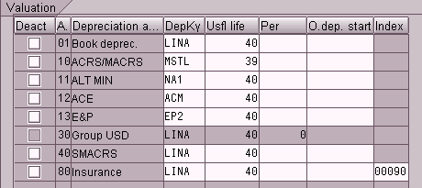

Field Name | Description | R/O/C | User Action and Values | Comments
Deact. | Deactivate Depreciation Area | O | Will deactivate depreciation area
Depreciation Area | Depreciation Area | R | Will default from asset class
Depreciation Area Description | Depreciation Area Description | R | Will default from asset class
Depreciation Key | Depreciation Method | R | Will default from Asset Class. These keys may be manually overridden.*
Useful Life | In years | R | Will default from Asset Class. These keys may be manually overridden.*
Useful life per | In months | O | Used for partial year depreciation
O. Depreciation Start | Depreciation calculation start date | O | Automatically populated based on Depreciation Key. These keys may be manually overridden.*
Index | Index series for replacement value | R | Avail for calculation of replacement values; Defaulted from asset class.

(NOTE: On the above table, in column “R/O/C”; “R”=Required, “O”=Optional, “C”=Conditional)

Press the SAVE icon or Asset → Save to save the Asset Master Record. At the bottom of screen, a message will say that an asset number was created.
  - Use the green arrow icon to exit or press F-3

