Changes to Reason Codes for DMC and AR

Changes to Deduction Management: Action Codes and Descriptions

From IMG:
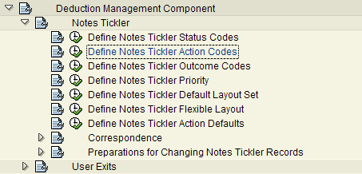

EN | 1CA | First Call to Cust | 1
EN | 2CA | Second Call to Cust | 5
EN | ACP | Act clearing pending | 5
EN | ADJ | Adjustment Done | 1
EN | CC | Credit Card Payment | 1
EN | CFC | Clm filed w/carrier | 1
EN | CPP | Customer pmt plan | 5
EN | CSA | Cust Serv action req | 5
EN | DL | 10 Day demand ltr | 10
EN | EML | Email to customer | 1
EN | FAX | Fax Invoice to Cust | 1
EN | FLC | Flooring Credit | 1
EN | FUP | Follow Up Call | 1
EN | IDR | Inv bal dlr research | 5
EN | IFR | Inv bal Fen research | 3
EN | INC | Incoming Call | 1
EN | ITP | Inv transfer pending | 7
EN | MES | Message Left | 1
EN | PCA | Pending Claim | 1
EN | POD | Request proof of del | 2
EN | PRS | Product to be scrap | 5
EN | PRT | Product to be return | 15
EN | REO | Reorder needed | 2
EN | WOR | Write-off required | 5

Changes to Classification of Payment Differences: Overview

From IMG:
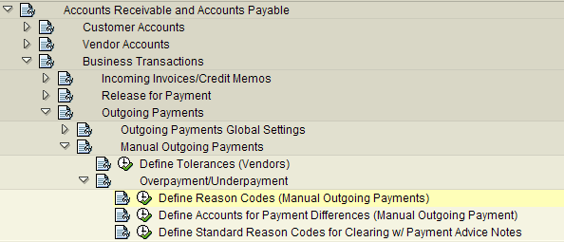

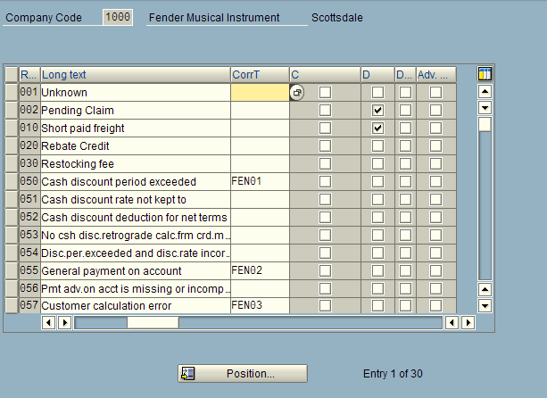

Additional Data:

1. Correspondence Type for Reason Code
Type of correspondence which is to be created with the specified reason code in the case of payment differences. The requirement is that only this reason code occurs in the clearing procedure and that it was agreed that a payment notice is to be created for payment differences (residual item, partial payment, payment on account) for the customer/vendor tolerance group.

Procedure
Enter the correspondence type if you have defined a specific form of payment notice for the reason code.

2. Indicator: Charge off difference via separate account
Indicator that payment differences with this reason code are charged off via a separate G/L account. The accompanying account is specified in the configuration menu depending on the reason code.

3. Indicator: Disputed item?
Indicator which should cause a disputed item from payment differences with this reason code during residual item formation.
Disputed items do not raise the total receivables for a customer in the framework of the credit management program.
Disputed items can be displayed separately in the line item display and in credit management.
In credit reviews, disputed items are not considered against the oldest open items nor against that percentage of open items with a specific number of days in arrears.
Changes made and entire tables listed below:
1 | Unknown | Unknown
2 | Pending Claim | Pending Claim
10 | Short paid freight | Short paid freight
20 | Rebate Credit | Rebate Credit
30 | Restocking fee | Restocking fee
50 | Cash discount period | Cash discount period exceeded | FEN01
51 | Cash discount rate | Cash discount rate not kept to
52 | Cash discount f. net | Cash discount deduction for net terms
53 | Cash discount retro. | No csh disc.retrograde calc.frm crd.memo
54 | Disc.period and rate | Disc.per.exceeded and disc.rate incorr.
55 | Pmnt on acct | General payment on account | FEN02
56 | Pmnt advice error | Pmt adv.on acct is missing or incomplete
57 | Calculation error | Customer calculation error | FEN03
58 | Debit reduced | Debit reduced instead of paid | FEN04
59 | Debit paid twice | Debit paid twice | FEN04
60 | Credit memo paid | Credit memo paid instead of reduced | FEN05
61 | Credit memo twice | Credit memo reduced twice | FEN05
62 | Invoice paid twice | Invoice paid twice | FEN04
63 | Invoice pd from Dun | Already paid from dunn letter | FEN05
64 | Invoice pd from rfnd | Already deducted from refund check | FEN05
65 | Pd inv clr by cr mem | Paid invoice cleared by cr memo | FEN05
66 | Used cr memo not ava | used credit memo not available | FEN05
ALL | Allowances | Allowances
BDE | Bad Debt | Bad Debt
BNK | Bank Fees | Bank Fees
CLI | Clear Invoice | Clear Invoice
DIS | Discounts | Discounts
EML | Email to Customer | Email to Customer
FAX | Fax Invoice to Cust | Fax Invoice to Customer
FCH | Finance Charges | Finance Charges
IDR | Inv bal Dlr research | Invoice balance Dealer to research
IFR | Inv bal Fen research | Invoice balance Fender to research
INT | Interest | Interest
ITP | Inv transfer pending | Invoice transfer pending
MIS | Missing product | Missing product
OLD | Converted | Converted
PCA | Pending Claim | Pending Claim
POD | Request proof of del | Request proof of delivery
PRC | Pricing | Pricing Issue
PRS | Product to be Scrap | Product to be scrapped
PRT | Product to be return | Product to be returned
REO | Reorder needed | Reorder needed
TCP | Traffic claim pendin | Traffic claim pending
WOR | Write-off required | Write-off required
___ | ____________________ | ________________________________________ | _____
1 | Unknown
2 | Pending Claim
10 | Short paid freight
20 | Rebate Credit
30 | Restocking fee
50 | Cash discount period
51 | Cash discount rate
52 | Cash discount f. net
53 | Cash discount retro.
54 | Disc.period and rate
55 | Pmnt on acct
56 | Pmnt advice error
57 | Calculation error
58 | Debit reduced
59 | Debit paid twice
60 | Credit memo paid
61 | Credit memo twice
62 | Invoice paid twice
63 | Invoice pd from Dun
64 | Invoice pd from rfnd
65 | Pd inv clr by cr mem
66 | Used cr memo not ava
ALL | Allowances
BDE | Bad Debt
BNK | Bank Fees
CLI | Clear Invoice
DIS | Discounts
EML | Email to Customer
FAX | Fax Invoice to Cust
FCH | Finance Charges
IDR | Inv bal Dlr research
IFR | Inv bal Fen research
INT | Interest
ITP | Inv transfer pending
MIS | Missing product
OLD | Converted
PCA | Pending Claim
POD | Request proof of del
PRC | Pricing
PRS | Product to be Scrap
PRT | Product to be return
REO | Reorder needed
TCP | Traffic claim pendin
WOR | Write-off required

