Grouping Recurring PO Payments
Following is a change in process for processing payment of recurring POs.
- On Parameter Tab enter
Vendor : 0 to ZZZZZZZZZZ
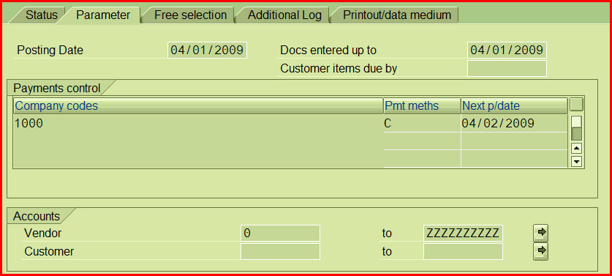

- On Free selection Tab enter
Field Name: Reference key 3
Value: RECURRING PO

